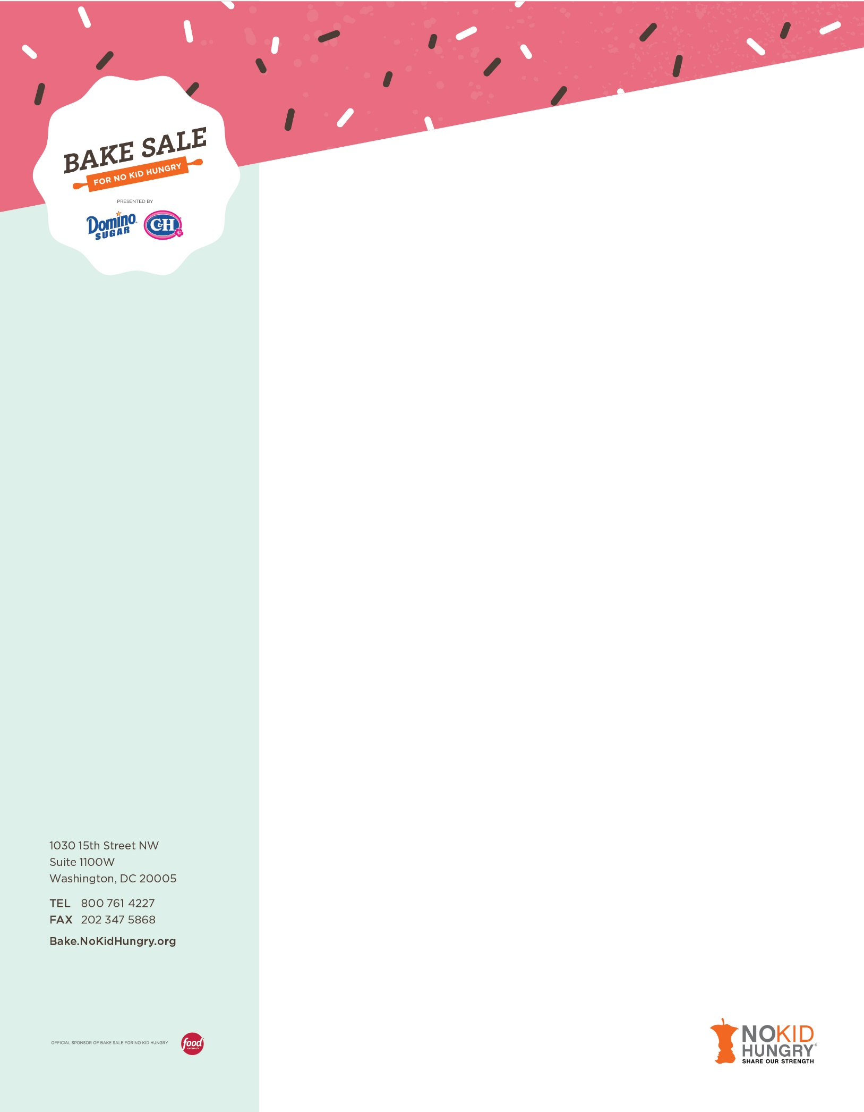

Dear Name,

I am contacting you regarding (insert bake sale team) to support Share Our Strength’s Bake Sale for No Kid Hungry™, a national effort that encourages Americans to host bake sales in their communities to help end childhood hunger. Our bake sale is taking place on (insert bake sale date) and we hope to raise (insert goal), but we need your help! Please join us in ending childhood hunger by contributing to our bake sale OR to our bake sale and raffle by donating (insert your request: you could ask for – baked goods OR raffle items: merchandise, gift cards, gift baskets or another item – be creative!).
Today, nearly 1 in 6 children in America do not know when their next meal will come. That’s more than 13 million! But there is hope. Funds raised through Bake Sale for No Kid Hungry support Share Our Strength’s No Kid Hungry campaign. Nationally, the campaign provides leadership, raises awareness and advocates for change that will make sure no kid in America ever goes hungry. Locally, Share Our Strength funds the most effective anti-hunger organizations and builds partnerships that bring together public officials, nonprofits, community groups, private funders and businesses to end childhood hunger in a particular state or city. To learn more about the work being done through No Kid Hungry visit NoKidHungry.org.
Thank you for your time and consideration. I hope you will join our efforts, by donating (insert item requested). Please contact me with any questions at (XXX)XXX.XXXX.
Please send any contributions to:
Insert Name
Address
City, State, Zip

Thank you,
Name
Share Our Strength is a 501(c)3 private, nonprofit dedicated to ending childhood hunger in America. Federal Identification Number 52-1367538

